

**Department of Mechatronics Engineering**

**Solid Modeling and Manufacturing Process**

**Final Project Report**

**All in One Car (Line Follower, Obstacle Avoider,RC Car, Fire Extinguisher)**

**Name:** Faiq Nasir

**Roll Number:** 201075

**Class:** BEMTS-3-B

**Submitted To:** Engr. Nouman Ghafoor

**Date:** December 18th, 2021

Final Project Report

Objective 4

Components 4

1. Arduino UNO 4

2. Motor Driver (L298N) 4

3. Battery 4

4. Ultrasonic Sensor 4

5. Infrared Sensor 4

6. Temperature Sensor 4

7. Servo Motor SG90 5

8. Servo Motor Horn 5

9. Small 12V DC Motor 5

10. Propellers 5

11. Bluetooth Module HC-05 5

12. Switch 5

Working Principals 6

Line Follower 6

Obstacle Avoiding 6

RC Car 6

Fire Extinguisher 6

Infrastructure (Frame of Robot) 7

Bottom Base 7

Top Base 7

Connecting Rods 8

Assembly With Componets Attached 8

Assembly Without Components Attached 9

Isometric Drawing Views 9

Simulaton (Factor of Safety) 10

Conclusion 10

Project Report

# Objective

The objective of my final project is to make an All in One robotic car that can perform all the functionalities of a line follower, fire extinguisher, RC car and obstacle avoiding. All we nned to change is the code on Arduino UNO at the time of need.

# Components

## Arduino UNO

The Arduino Uno is an open-source microcontroller board based on the Microchip ATmega328P microcontroller and developed by Arduino.cc. The board is equipped with sets of digital and analog input/output pins that may be interfaced to various expansion boards and other circuits

## Motor Driver (L298N)

At the heart of the module is the big, black chip with chunky heat sink is an **L298N**. The **L298N** is a dual-channel H-Bridge **motor driver** capable of driving a pair of DC motor.

## Battery

A battery is a source of electric power consisting of one or more electrochemical cells with external connections for powering electrical devices such as flashlights, mobile phones, and electric cars.

## Ultrasonic Sensor

Ultrasonic transducers and ultrasonic sensors are devices that generate or sense ultrasound energy. They can be divided into three broad categories: transmitters, receivers and transceivers

## Infrared Sensor

An infrared sensor (IR sensor) is a radiation-sensitive optoelectronic component with a spectral sensitivity in the infrared wavelength range 780 nm … 50 µm.

## Temperature Sensor

A temperature sensor is **a device used to measure temperature**. This can be air temperature, liquid temperature or the temperature of solid matter.

## Servo Motor SG90

A servomotor is a rotary actuator or linear actuator that allows for precise control of angular or linear position, velocity and acceleration

## Servo Motor Horn

It is an attachment for servo motor.

## Small 12V DC Motor

A **DC motor** is any of a class of rotary electrical motors that converts direct current electrical energy into mechanical energy.

## Propellers

A **propeller** is a device with a rotating hub and radiating blades that are set at a pitch to form a helical spiral, that, when rotated, exerts linear thrust of air.

## Bluetooth Module HC-05

The **HC**-**05** is a very cool **module** which can add two-way (full-duplex) wireless functionality to your projects

## Switch

In **electrical** engineering, a **switch** is an **electrical** component that can disconnect or connect the conducting path in an **electrical equipment.**

# Working Principals

## Line Follower

The two infrared sensors attached at the front of the car will sense the line and car wll follow the line and the steering will be controlled by servo motors.

## Obstacle Avoiding

The four ultrasonic sensors attached at each side of car’s base will calculate the distance of car from obstacle from each side. As the car reaches certain distance from the obstacle aurduino will send signal to servo motors to make the turn and avoid the obstacle.

## RC Car

The Bluetooth Module can be connected with mobile and mobile can be used to send different signals to arduino which in turn send signals to servo motor or DC motors to move forward or make the turn.

## Fire Extinguisher

Temperature sensors attached on the sides of car base will calculate the temperature at sides of car base as the temperature reaches a certain limit the DC motors attached to the propeller will power up and try to extinguish the heat source.

# Infrastructure (Frame of Robot)

Most parts of body from are made from arcrylic plastic as it is more reliable form of the plastic and has enough strength to support all the sensor and components attached on the robotic base. I have created 2 baese and joined them through the connecting rod that is connected with both of the bases by slots So I will be easy to remove them whenever needed.

## Bottom Base

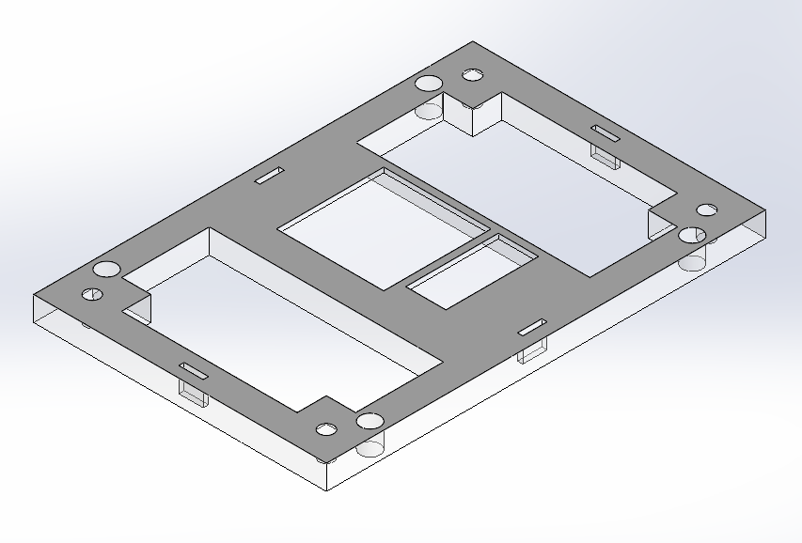

## Top Base

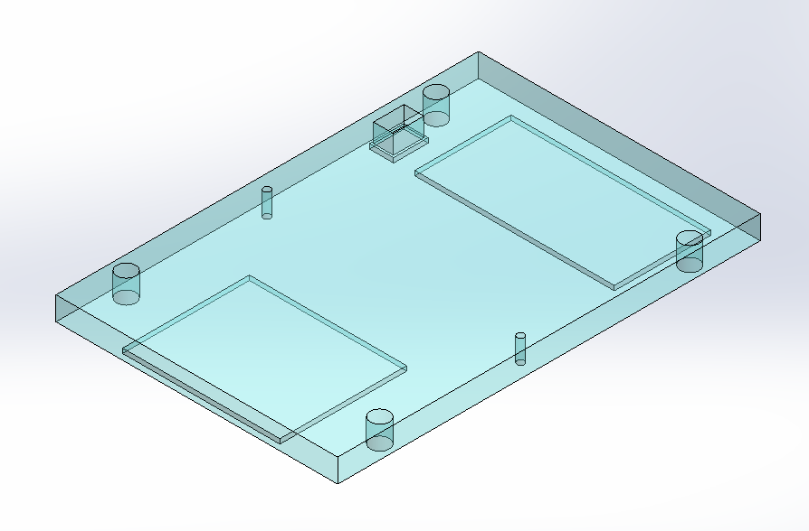

## Connecting Rods

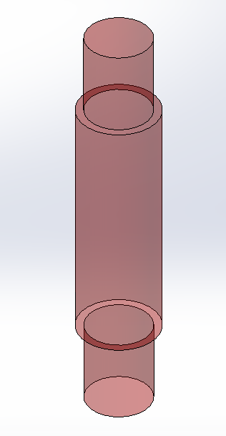

## Assembly With Componets Attached

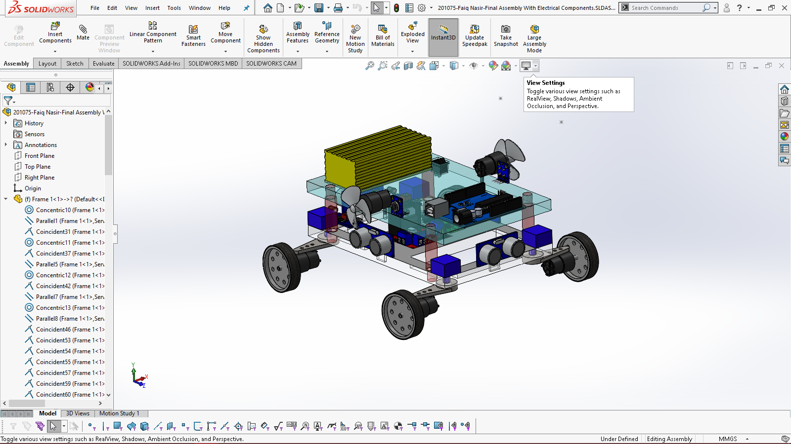

## Assembly Without Components Attached

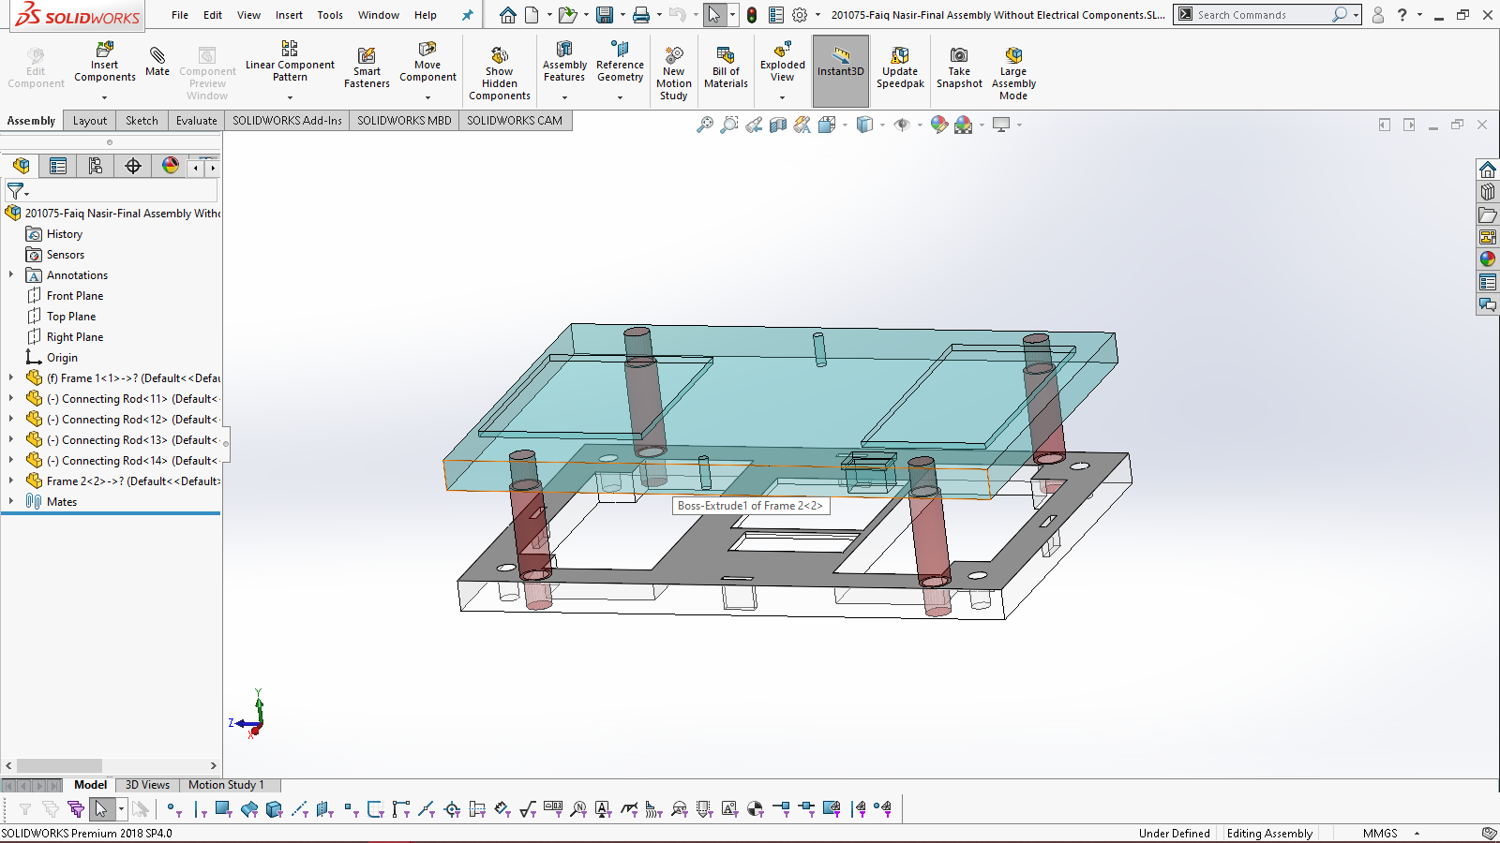

## Isometric Drawing Views

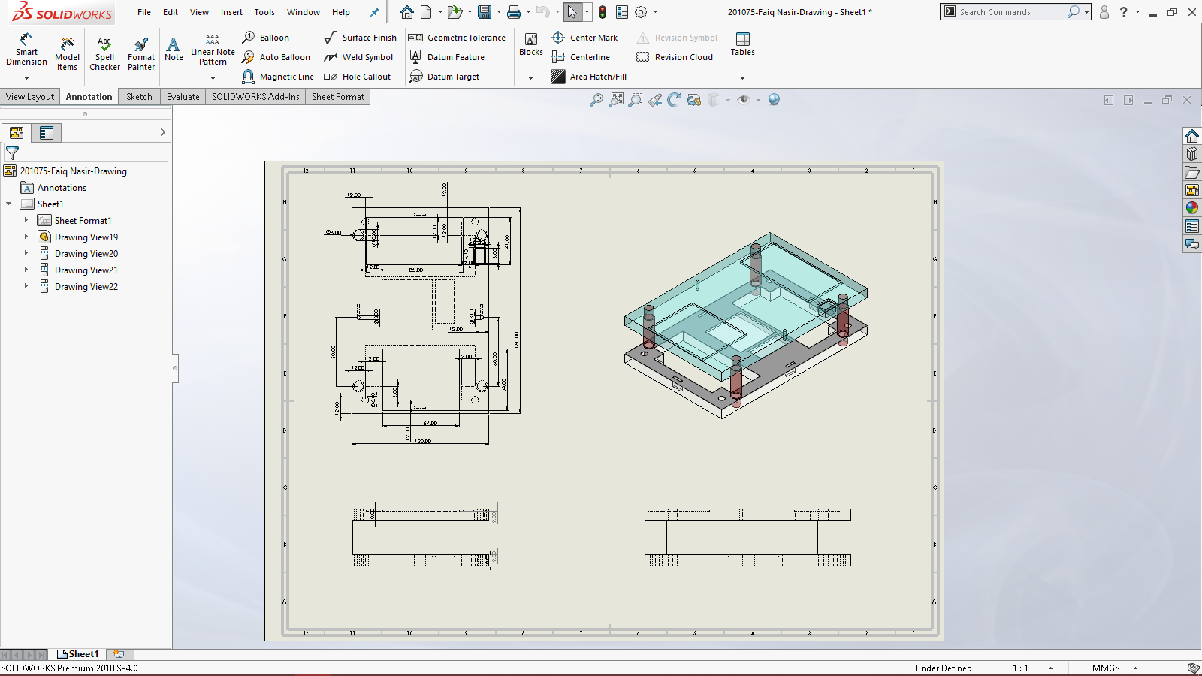

# Simulaton (Factor of Safety)

I have applied 40N force each on the upward and downward base excluding the weights of the components. Then I separately applied the weight of all the sensors and microcontroller in their slot and set the mesh production to coarse and set the fixtues at the bottom of 2 connecting rods and then ran the simulation to observe the factor of safety (FOS), Stress, Strain etc. The FOS came out to be 2.1 which met my requirement.

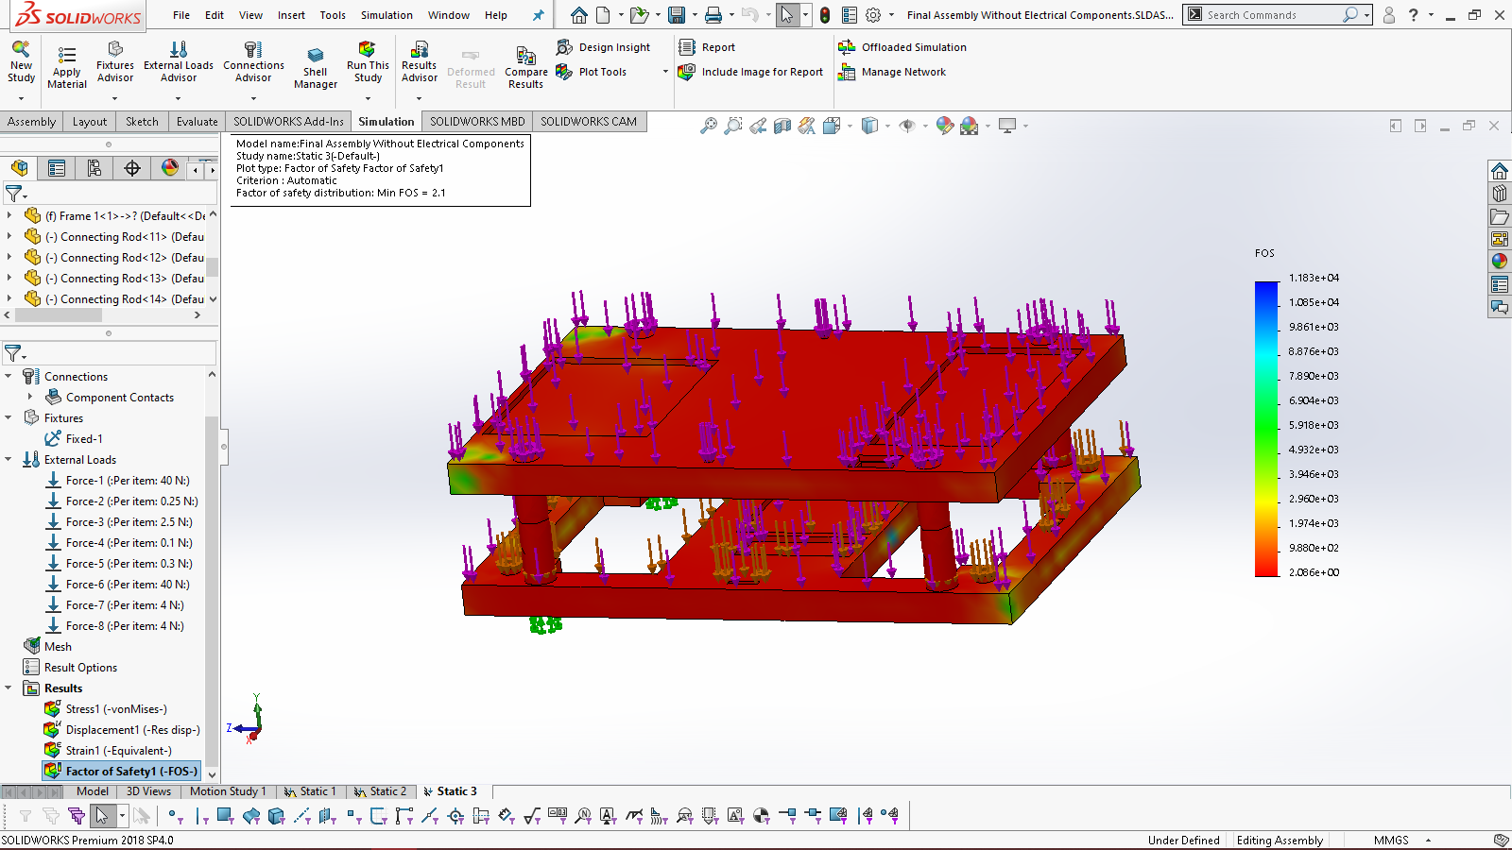

# Conclusion

In this final project I have learned how to design and assemble a projects body part by keeping all the factors like measurements, factor of safety, stress and strain in view and build base for the project according to requirements. I have also learned about different sensor and microcontroller (Arduino). And how to control sensors using microcontroller.